Public Housing Blog Draft

The Department of Housing and Urban Development (HUD) proposed a rule in April 2019 that would restrict housing assistance for mixed-citizenship families. The policy proposal marks yet another way that the Trump administration is targeting immigrant families and undocumented immigrants. One of several restricted federal housing programs, public housing allows for “mixed citizenship families,” households that contain members who are not citizens and do not have qualifying immigration status, to be eligible for assistance. Under the current system, households with undocumented immigrants or individuals with otherwise “ineligible” immigration status can receive subsidized or public housing, as long as at least one other member of the household is a citizen or has eligible noncitizen status, which includes individuals who are lawful permanent residents, refugees, or asylum seekers. However, the proposal would change affordable housing qualifications to ban federal housing assistance for households with at least one undocumented immigrant (CityLab, 2019).

Though Ben Carson, the HUD Secretary, has claimed that the new rule would cut down on long waiting lists for public housing, former secretary Julián Castro has asserted, “The bottom line is that our government is terrorizing families — first with ICE raids, now with evictions” (NYTimes, 2019). The proposal affects public housing, project-based rental assistance units, and Housing Choice Voucher (Section 8) recipients, and according to HUD reports, would evict 32,000 households from their subsidized home, amounting to 108,000 people and 55,000 children (NYTimes, 2019). Though the policy still remains a proposed rule in the Federal Register, it signals that immigrant families are facing a growing risk of being ejected from public housing units and permanently losing future eligibility.

But discrimination against immigrants and people of color is not a novel concept in the history of federal housing assistance. Since the 1930s, the federal government has provided various forms of housing assistance to low-income families to increase the affordability of housing, offering public housing and homeownership and rental housing assistance. In public housing, low-income tenants reside in housing developments owned and managed by local public housing agencies and pay a subsidized rental payment. However, governments and real estate agents promoted racial segregation through exclusionary and discriminatory housing policies, imposing racial restrictions on residences, engaging in redlining, and devaluing property based on the racial composition of residents. This legacy of state-sponsored racial segregation continues to influence the racial dynamics of cities and public housing, which continues to be one of the largest federal housing programs and houses over 950,000 households (Center on Budget and Policy Priorities, 2019).

Using data from the 2017 American Housing Survey, which is sponsored by HUD and conducted by the Census Bureau, we conduct an analysis of households in public housing by a variety of demographic factors, including race, ethnicity, and gender.

Black or African American households have the greatest percentage in public housing, with 6.4% (± 0.6) of households in public housing, and White alone households have the smallest percentage in public housing, at 1.1% (± 0.1). As expected, racial minority and Hispanic or Latinx households are much more likely to be in public housing than While alone households. A significantly greater proportion of female-headed households than male-headed households also rely on public housing, 2.9% (± 0.2) as compared to 0.95% (± 0.1). This trend may be driven by the higher rates of poverty among women than among men, as well as occupational segregation, and housing discrimination (A Gender Lens on Affordable Housing), which holds true for most racial and ethnic groups. While Black or African American households headed by women are the most likely to be in public housing, White households with headed by men are the least likely to be in public housing, 7.8% (± 0.8) as compared to 0.7% (± 0.1). Households that are AIAN alone, Hispanic of any race, and Asian alone, and with either female or male householders, are significantly more likely to be in public housing than are White alone households with a male householder.[1]

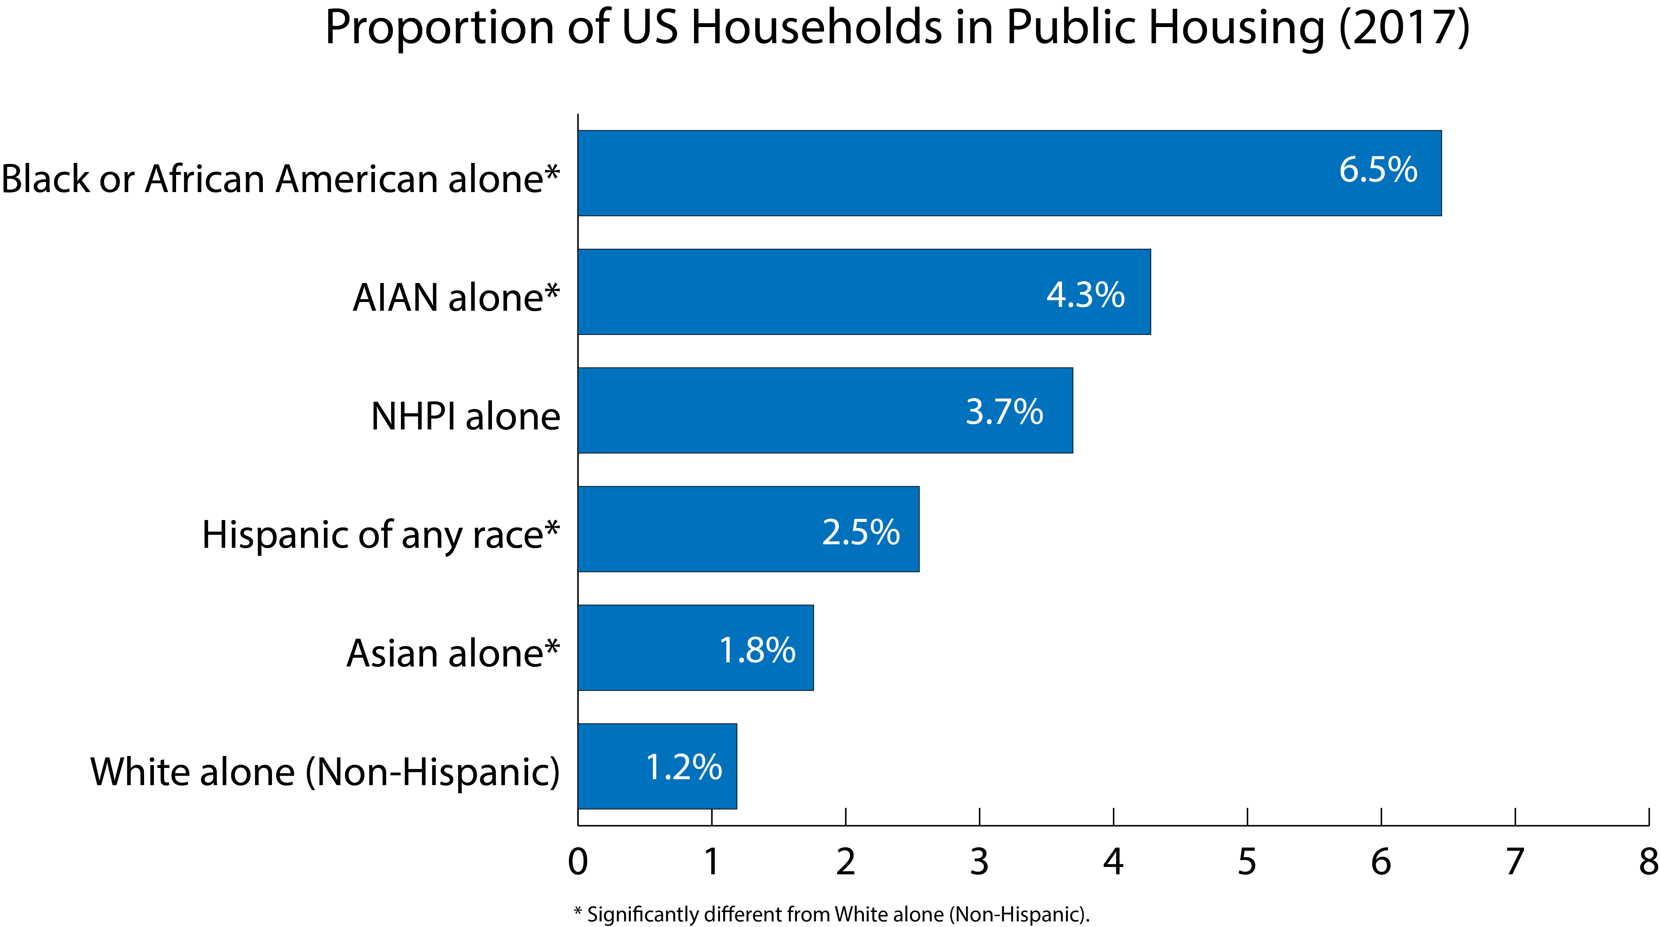

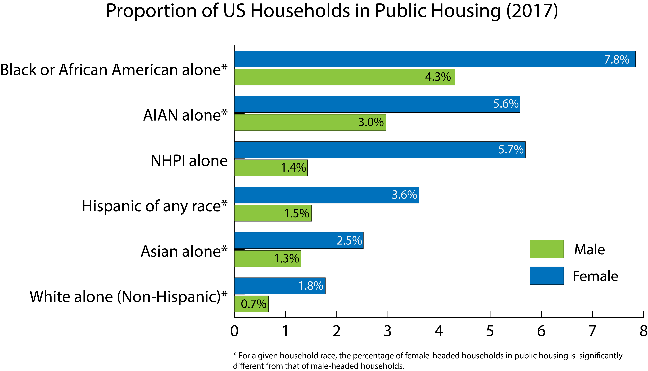

Education levels of householders also impacts the likelihood that a household will be in public housing. Our analysis confirms that households with heads that have higher levels of educational attainment are less likely to live in public housing. While 5.8% (± 0.6) of households with heads that have less than a high school education live in public housing. Even across racial and ethnic groups, householders with below a high school education level are significantly more likely to rely on public housing. While this may be tied to income levels, it may also be a result of differences in literacy in the housing application process.

Households with heads who are US citizens, both naturalized and native, are more likely to be in public housing than are households with at least one citizen, whom is not the householder, with 2.0% (± 0.1) as compared to 1.4% (± 0.5), respectively. However, there is no significant difference between the proportion of households in public housing without any citizens in the household and those with at least 1 citizen, but whom is not the householder. Trends in public housing reliance by household citizenship status differ slightly by race, with significant differences for Black or African American households and Hispanic/Latinx households.

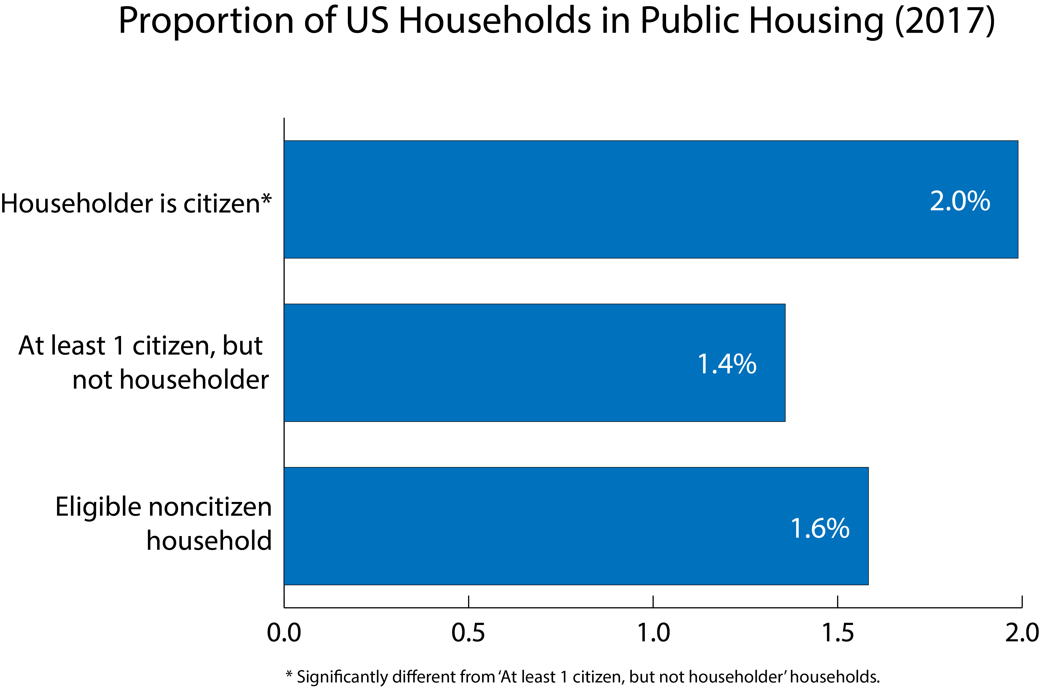

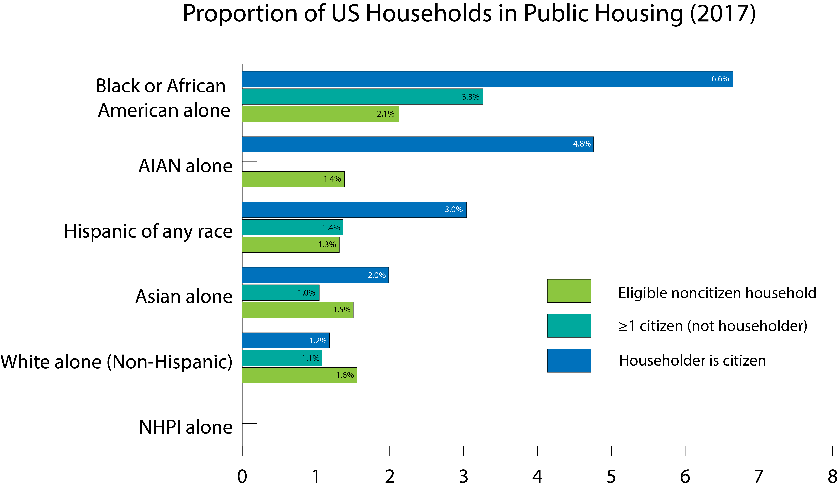

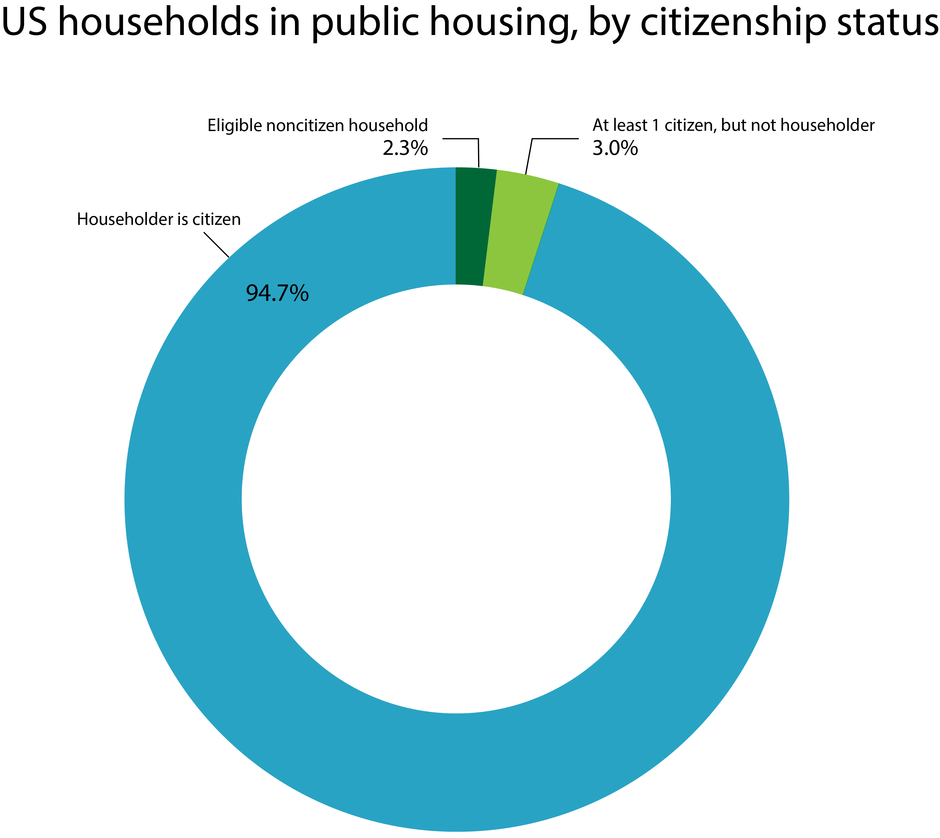

Sources

* Affordable housing online: <https://affordablehousingonline.com/guide/housing-for-immigrants/eligible-noncitizens>
* Congressional Research Service:<https://crsreports.congress.gov/product/pdf/RL/RL34591>
* Urban Institute:<https://www.urban.org/sites/default/files/publication/94146/trends-in-housing-problems-and-federal-housing-assistance.pdf>
* Center on Budget and Policy Priorities, Federal Rental Assistance Fact Sheet:<https://www.cbpp.org/research/housing/federal-rental-assistance-fact-sheets#US>
* A Gender Lens on Affordable Housing: <https://www.icrw.org/wp-content/uploads/2016/11/gender_lens_on_affordable_housing_by_regender_final-1.pdf>
* NYTimes, 2019, “HUD Moves to Limit Public Housing Aid for Undocumented Immigrants,” <https://www.nytimes.com/2019/04/17/us/politics/hud-public-housing-immigrants.html>
* CityLab, 2019, “Why HUD Wants to Restrict Assistance for Immigrants, ” <https://www.citylab.com/equity/2019/04/public-housing-rent-assistance-immigrant-families-hud-policy/587479/>

Types of housing subsidies:<https://tenantsunion.org/rights/types-of-housing-subsidies>

1. Estimates for NHPI households have significant margins of error for both female and male householders, both of which are above 95%.